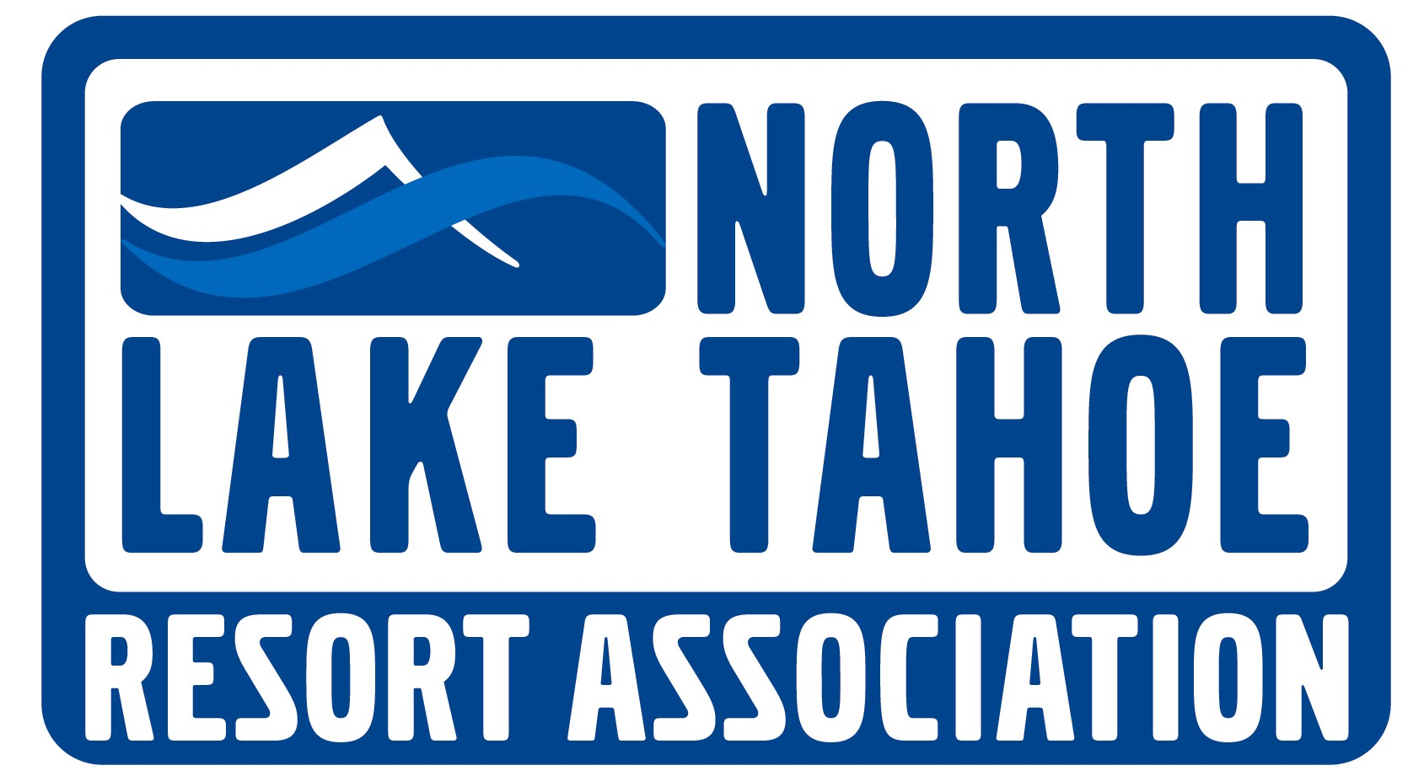

PO Box 5459 - Tahoe City, CA 96145 Ph – (530) 581-8700 Fx – (530) 581-8762

MARKETING COMMITTEE MEETING MINUTES
June 28, 2011 – 1 pm

Tahoe City Public Utility District-Conference Room
PRELIMINARY MINUTES

COMMITTEE MEMBERS IN ATTENDANCE: Barb Cohen, Kevin Hickey, Becky Moore, Les Pedersen, Jennifer Merchant, Deanna Gescheider and Ron Parson

RESORT ASSOCIATION STAFF: Andy Chapman, Sandy Evans Hall and Emily Sullivan

OTHERS IN ATTENDANCE: Wendy Hummer, Cathy Davis, Kerstin Plemel, Mike Williams, Shelley Fallon, Ralf Garrison and Pettit Gilwee

I. MEETING OF THE MARKETING COMMITEE

1.0 CALL TO ORDER – ESTABLISH QUORUM

1.1 The Marketing Committee meeting was called to order at 1:10 pm by Chair Les Pedersen and a quorum was established.

- PUBLIC FORUM

2.1 No public forum

- AGENDA AMENDMENTS AND APPROVAL

3.1 M/S/C (Cohen/Williams) (8/0) to approve the agenda exchanging the Conference Report with the MTRiP report.

4.0 APPROVAL OF THE MARKETING COMMITTEE MINUTES FROM THE MEETING ON MAY 24, 2011

4.1 M/S/C (Cohen/Pedersen) (8/0) to approve the Marketing Committee meeting minutes from May 24, 2011

- PRESENTATION ON MTRiP PROGRAM AND SEASON REVIEW

5.1 Ralf Garrison presented on the Mountain Travel Research Program (MTRiP). This is the fourth year that MTRiP has been collecting data for the NLTRA. He reviewed the current program. The data is complied from many different entities such as lodging properties in different destinations to allow destination comparison. They also collect economic indicators; the combination of the different types of data gives information concerning destination mountain travel. The data is also used to compare one destination from year to year and against other destinations.

5.2 New opportunities. He suggests obtaining additional participation from additional lodging properties in NLT and looking at subsets of properties (regional segment reports). There is a cost involved, $1,500 (all properties could pay in). A comparison could be made between condos and hotel rooms. He also suggested adding a daily occupancy report.

5.3 He reviewed the last winter 2010-11 (November through April), the industry as a whole and then specifically North Lake Tahoe. The industry is up 6% Tahoe is up 4%. Tahoe had a strong performance of occupancy and held its own in the marketplace. He reviewed the daily occupancy in the winter 2010-2011 and the skier visits over the years. The summer occupancy industry is up 7%, with NLT up 13% and rates in Tahoe are up 2%.

- PRESENTATION AND DIRECTION ON NORTH LAKE TAHOE CONFERENCE SALES PROGRAMS

6.1 Jason Neary presented on the direction of the North Lake Tahoe Conference Sales program. The NLTRA Board asked staff to review the Conference Sales efforts to maximize conference business in NLT. Andy reported on the Advisory Committee recommendations; reducing media expenditure, buffing up sales efforts through face-to-face sales by moving out of national traditional media and hiring additional sales staff. Staff is recommending the following based on the suggestions from the Conference Sales Advisory Committee meeting:

- Budget preparation to include new sales position beginning October 2011
- Decrease Cooperative Conference media budget from $175,000 to $145,000
- Increase sales efforts budget from $45,000 to $55,000

6.2 Jason reviewed the results of the Meeting Mart Survey. Becky asked if Jason could resend the survey to her. He also reviewed the Conference Sales budget.

The Committee recommended the following:

- Market the vast amount of meeting space in NLT with a focused strategy, such as, “Tahoe is a great place to have meetings.”
- Suggested sales efforts be driven at groups/associations focused on paddle-sports, Nordic skiing and biking. Look at proactive sales efforts through events by actively selling to groups/associations in conjunction with those events.
- Requested a presentation from Smith and Jones concerning the current Conference Sales marketing plan at the next Marketing and Board meetings.
- Requested the Conference Sales Advisory Committee provide a clear plan for the Marketing Committee to review.
- Would like cohesive strategy/goals concerning the new proposed sales person including a return on the investment of new staff.
- Requested that the Marketing Committee annually review the Conference Equity report and include it in the Marketing Packet.

Action: Becky asked if Jason could resend the survey to her.

- NLTRA FY 2011/12 BUDGET REVIEW AND APPROVAL

  - Andy stated that the review on the 2011/12 will be moved to the next Marketing Committee Meeting.

Action: Review the 2011/12 Budget at next Marketing Committee Meeting

- DISCUSSION AND DIRECTION TO NLT COOPERATIVE COMMITTEE ON FY 2011/12 MARKETING COOPERATIVE BUDGET

8.1 Andy reviewed the Draft Marketing Cooperative Budget. The funding of the Co-op is based on a percentage of total TOT. Staff has suggested a reduction to the overall NLTRA funding of the Co-op budget of $50,000 devoting those resources to a new sales position. Andy is looking for input from the Committee to bring forth to the Marketing Co-op meeting tomorrow.

The Committee had the following suggestions/questions:

- Decreasing the destination and increasing the drive percentages.
- Increasing funds focused on internet and social media.
- More detail in the budget (reasoning behind the changes) and strategic elements within the budget.
- More market research on media consumption.
- Questioned contribution to the NTPUD concerning the conference center and the return on the investment.

8.2 Barb requested an action item sheet for each Committee. Sandy is implementing a Committee action sheet that will be included in the Board Packet each month.

- DISCUSSION ON RENO TAHOE INTERNATIONAL AIRPORT NORTH LAKE TAHOE WELCOME CENTER OPPORTUNITY

9.1 Sandy stated that the NLTRA is signing a lease for a new Welcome Center at the Reno Tahoe International Airport; the rent will total $40,000/year. There will be $20,000 budgeted for staffing. The first four months it will be staffed solely by the NLTRA; once a shuttle operator has been identified they will move into the Welcome Center and staffing duties will be shared. The information booth will provide information concerning transportation and visitor information available throughout North Lake Tahoe. Staff will be looking at obtaining other partners to share the costs from Washoe County or Truckee. It will open August 1, 2011 and it will be located across from baggage claim in the RTO.

- NLTRA BOARD RETREAT UPDATE

10.1 The NLTRA Board met on June 22nd. They created three additional key initiatives, biking, paddle-sports and Nordic skiing. They also set strategic goals for the next 3 to 5 years within the core functions: Infrastructure/ Transportation, Membership Services/Economic Development/Business Advocacy, Marketing/Sales, Visitor Information/Lodging Liaison and Community Relations. Some of the strategic goals are:

Infrastructure/ Transportation

- By 2016-Upgrade lodging and commercial core to include 5 new developments (one considered a signature lodging product).
- Be proactive within the infrastructure and transportation and taking a stronger role in the NLT environment.
- By 2016-Work on current trails, filling in the entire trail system linking all areas within NLT regional triangle and West Shore to Incline
- By 2014-Add 30 Way-finding signs, providing more directional signage in NLT.
- By 2016-There will be an additional 50,000 seats annually into Reno or Sacramento Airport.
- By 2016-Work on transportation system to conveniently link visitors to recreation and lodging product. Goal set nothing greater than a half hour service in the peak season.

Membership Services/Economic Development/Business Advocacy

- By 2016-Increase dues and membership by 20%
- By 2016-NLTRA will take the lead to improve the regulatory environment.
- By 2013-Put annual plan in place for legislative action to assist lobbyist with being proactive on our behalf.
- By 2013-NLTRA will take the lead on components of the Economic Prosperity Plan, Redevelopment Plan and County Road Map.

Marketing/Sales
- By 2016-Occupancy during the strike zone periods will have increased by 5% and all annual occupancy for all lodging will be at 60%
- By 2016-NLT region will be competitive in total skier days and will dominate the California market as a destination for alpine and Nordic skiing, biking and paddle-sports
- By 2012-Marketing department will have a clear marketing brand for NLT through a community branding process
- By 2016-TOT will have increased by 10%
- By 2014-Conference revenue and attendance will have grown by 25%

Visitor Information/Lodging Liaison
- By 2012-Create a region-wide visitor information strategy to reach out to in-market guests to try and extend their stays. Increase communication and outreach strategy. Have visitor information centers in the Reno Airport and Auburn.

Community Relations
- By 2016-The organization will have built trust, confidence and leadership with key partners.

  - The next step will be confirming the strategic goals with the NLTRA Board at their next meeting. After the goals are set, staff will create action plans to move forward with the plan. The Committee asked what strike zones were used in the creation of the above strategic goals. The NLTRA Board used the strike zone chart that is currently in place for Marketing.

  - DISCUSSION AND POSSIBLE ACTION TO RESCHEDULE THE JULY MARKETING COMMITTEE MEETING TO JULY 19TH

11.1 The Committee agreed to move the Marketing Committee meeting to July 19th

12.0 DEPARTMENTAL REPORTS-

12.1 Advertising- Smith and Jones reported on the marketing plan that is located in the Marketing Packet for the early season media. Mike stated that there has been some changes to the Lodging portion of the website and is conducting a test on ‘stay’ vs. ‘lodging’. They have added different sort options to the dining portion of the website. They are currently in the process of conducting research on mobile applications. Mike stated that he is working on the event calendar and how it can be made easily distributable to hotel guests.

12.2 Conference Sales-The Conference Sales report is located in the Marketing Packet.

12.3 Leisure Sales-Jeremy’s report is located in the Departmental Reports section of the marketing packet

12.4 Special Projects-Judy’s report is located in the Departmental Reports section of the marketing packet

12.5 Web-Shelley reported on the Web report. She stated that the people have been busy entering events into the Calendar of Events on www.gotahoenorth.com. Shelley, Judy and Mike are working to make it easier for people to enter in events in the future.

12.6 Public Relations-Pettit reported on the PR report located in the Departmental Reports section of the Marketing packet.

13.0 STANDING REPORTS

The following reports were posted on www.nltra.org:

- MAY MTRiP REPORT
- APRIL RENO TAHOE AIRPORT REPORT
- MAY SEARCH ENGINE OPTIMIZATION REPORT
- MAY WEB/GEO TRACKING REPORT
- MAY LODGING REFERRAL REPORT
- CONFERENCE ACTIVITY REPORT

14.0 COMMITTEE COMMENTS

14.1 Barb-gave direction to staff to plan meetings with interested parties concerning the three initiatives that the Marketing Committee created. She also requested a Brand review workshop at the next Committee Meeting. Andy stated that there is a cross country meeting scheduled this Thursday and staff is working on scheduling other meetings. Kevin reminded the Committee that the summer months are busy for a lot of businesses and it may be difficult to schedule meetings at this time.

14.2 Brett asked about the Fabulous Fall’s direction with food and wine. What is the food and wine focus for late August to early September and should lodging properties be putting events on ‘Cool Deals’. Andy stated the Committee will be reviewing and compiling a plan in the future. Brett suggested adding food, wine, breweries and spirit events to the plan.

14.3 Ron discussed the 3 initiatives and how it applies to the marketing plans in place at this time. He suggested keeping a list of initiatives the Committee is focused on and what is being done to support the initiative. Ron suggested changing the format of the Marketing agenda. The Committee should consider restructuring the meetings to ensure that all opportunities are being taken advantage of.

Action: Staff to work on new format for meeting agenda.
Action: Brand review workshop at the next Committee Meeting
Action: Review Fabulous Fall’s direction with food, wine and spirits and create a plan for the future.

15.0 ADJOURNMENT

15.1 The Marketing Committee meeting adjourned at 3:41 pm.

Submitted By:

Emily Sullivan, Programs Assistant
North Lake Tahoe Resort Association

