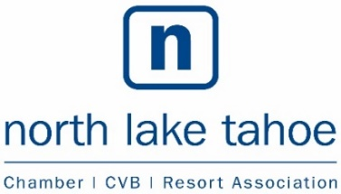
BOARD OF DIRECTORS
ORGANIZATIONAL DEVELOPMENT SESSION
Date: Wednesday, September 12th, 2018
Time: 1:30pm – 3:30pm
Location: Gar Woods Grill
5000 N Lake Blvd, Carnelian Bay
NLTRA Mission
To promote tourism and business through efforts that enhance the economic, environmental, recreational and cultural climate of the area.

[Cite your source here.]

Board of Directors:
Chair: Adam Wilson, Vail Resorts | Vice Chair: Samir Tuma, Tahoe City Lodge
Treasurer: Christy Beck, Squaw Alpine | Secretary: Brett Williams, Agate Bay Realty
Aaron Rudnick, Sierra Tahoe Recreation | Andre Priemer, Resort at Squaw Creek | Bruce Seigel, Ritz-Carlton, Lake Tahoe
Chris Brown, Elevation Law Firm | Dan Tester, Granite Peak Management | Gary Davis, JK Architecture Engineering | Greg Dallas,
Sugar Bowl Resort | Jim Phelan, Tahoe City Marina | Karen Plank, Placer County Appointee | Kevin Mitchell, Homewood Mountain Resort | Lynn Gibson, Keoki Gallery | Stephanie Hoffman, Granlibakken Tahoe | Tom Turner, Tahoe Restaurant Collection
Advisory Committee: Erin Casey, Placer County Executive Office, Tom Lotshaw, Tahoe Regional Planning Agency
AGENDA

Estimated
Time

1:30 p.m. 1. Call to Order – Establish Quorum

1:30 p.m. 2. Public Forum-Any person wishing to address the Board of Directors on items of interest to the Board
not listed on the agenda may do so at this time. It is requested that comments be limited to three minutes since no action may be taken by the Board on items addressed under Public Forum.

1:40 p.m. 3. NLTRA background and current perspectives on Chambers and DMO’s.
Guest speakers: Betty Gorman, from B Great Leadership (former CEO of South Tahoe Chamber)
Carl Ribaudo, President, SMG Consulting

3:30 p.m. 4. Adjourn.

At the conclusion of the Board meeting, the Board and facilitators
will participate in a workshop including: building board member commitments, team-building exercises, and leadership facilitation.

Posted online at www.nltra.org

