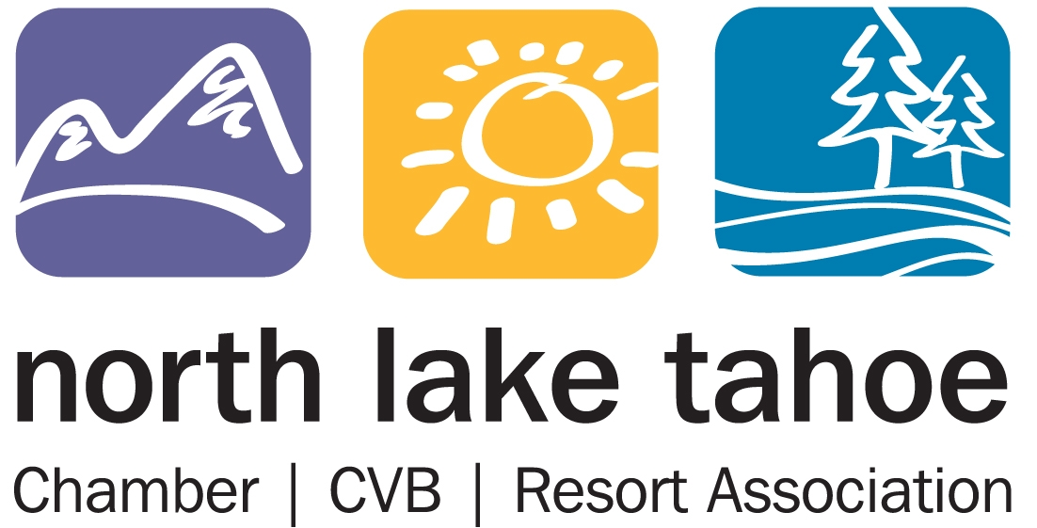

PO Box 5459 - Tahoe City, CA 96145 Ph – (530) 581-8700 Fx – (530) 581-8762

MARKETING COMMITTEE MEETING MINUTES
Tahoe City Public Utility District Board Room
Tuesday, May 30, 2017 – 2 pm

PRELIMINARY MINUTES

COMMITTEE MEMBERS IN ATTENDANCE: Brett Williams, Judith Kline, Carlynne Fajkos, Becky Moore, Marguerite Sprague, Erin Casey, DeDe Cordell, Todd Jackson

RESORT ASSOCIATION STAFF: JT Thompson, Amber Burke, Jason Neary, Sarah Winters, Sandy Evans Hall, Anna Atwood

OTHERS IN ATTENDANCE: Alexis Kahn, Lindsay Moore, Liz Bowling, Shelly Fallon, Andy Chapman, Walt McRoberts (called-in)

I. MEETING OF THE MARKETING COMMITTEE
1.0 CALL TO ORDER – ESTABLISH QUORUM

1.1 The Marketing Committee meeting was called to order at 2.07 pm and a quorum was established.

- PUBLIC FORUM

2.1 No public forum.

3.0 AGENDA AMENDMENTS AND APPROVAL

3.1 M/S/C (Sprague/Moore) (8/0) to approve the agenda as presented.

4.0 APPROVAL OF MARKETING MEETING MINUTES FROM APRIL 21, 2017

4.1 M/S/C (Cordell/Sprague) (8/0) to approve the meeting minutes from April 21, 2017 with the correction that Erin Casey did not call in but attend the meeting.

5.0 PRESENTATION & DISCUSSION – FY 2017/18 ADVERTISING STRATEGY – AUGUSTINE/RICHTER 7

5.1 Lindsay shared the FY 2017/18 Advertising Strategy and approach.
- The Top 3 ways to reach leisure travelers: Mobile, Content & Digital Marketing and Social Media. Content that converts: Things to do 80%, Dining 43%, Maps/destination landscape 42% and Events 31%.
- Consumer Path-to-Purchase: Inspirational stage influencers: Friends’ travel posts on social media: 1 in 4. Brand’s content on Social Media: 1 in 5. Cross-device research & bookings, 65% of those booking travel online began process with 2+ destination in mind.

Walt with Richter 7 shared the consumer journey strategy for next winter.
- Target when North Lake Tahoe can be more influential during destination timing. Bookers are still engaging with travel sites, but it is less likely that advertising will affect their decisions.
- Walt shared we want to align budget, timing and media channels as we want to impact early on in the journey.
- The best time to start advertising would be in the consideration stage when you can still influence the consumer.
Lindsay shared the objectives and considerations for FY 2017/18 and Consumer/Meetings & Convention Strategy.
- Some of the objectives include: position North Lake Tahoe as a year-round/four-season destination, Increase length of stay and visitor spending, Increase mid-week visitation.
- Things to Consider: 2016 Website User and Conversion Study Report, STRATA LA Survey, Performance of spring campaign, Visit California and Travel Nevada Opportunities.
- Consumer Media Approach: Continue using multiple vendors for lower costs and stronger results, Continue with Persona Targeting, Continue with Fly/Drive market strategy, Incorporate nice audience targeting for spring, summer & fall.
- Comments: Brett brought up don’t forget to target to the audience that likes less impact activities. Alexis shared that the content is specific to the audience they are targeting. Marguerite brought up same thing for Arts and Culture.
- Consumer Media Approach: Change KPI from booking to site engagement and quality of engagement. Incorporate geo-fencing when possible, incorporate rich media opportunities in overall digital plan, incorporate digital outdoor for LA market.
- Meetings Media Approach: Incorporate geo-fencing strategy at tradeshows and other events, Trade show pre-post communication, print (targeted media buy), Continue high frequency approach.
- Erin questioned what is different this year vs. last year strategy. Lindsay shared it’s mostly timing.

6.0 REVIEW AND DISCUSSION OF HUMAN POWERED SPORTS MARKETING CAMPAIGN SCOPE OF WORK – BURKE/KAHN

6.1 This budget was approved at the last meeting and also approved by the Board of Directors. Amber shared the detailed media plan.
- Comments: This budget will cover through what date? Amber shared through this summer.
- This plan ties in to the event and activity message
- Comments: Timing? Will this be pushing the shoulder and mid-week visitation? Amber shared they will come back with more information on this.
- Comment: Erin asked if the contract with Augustine was amended with additional scope of work? Amber and staff will discuss offline.
- Comments: Why was Search not included in this? Lindsay shared because of limited budget.
- Comments: How is ROI tracked? Alexis shared this is built more like a campaign so you can track ROI and it will also have a landing page.
Action to Amber: Share the creative for this campaign since it will go out before our next scheduled meeting.

7.0 UPDATE ON FINAL BACC BUDGET AND SCOPE OF WORK FOR SUMMER LONG MUSIC AND PEAK YOUR ADVENTURE PROGRAMS – BURKE/PARRISH

7.1 Amber shared the packet included final scope of work for High Notes and Peak Your Adventure Campaign. There were a few minor tweaks after the Board of Directors meeting. Update on High Notes.
- More content has been updated on High Notes landing page and links.
- A video will be made at Northstar at Beerfest & Bluegrass Festival. This will be integrated into the campaign.
- The High Notes logo will be faced out. It’s now being references as North Tahoe Summer Music Series. She explained the transition face out. (Hastag #highnotes will still be used but not the logo.)
- High Notes one sheet was distributed to all partners. Making an effort to make sure all partners have the information on High Notes. This is a great tool-kit of information. (This will also be done for Peak Your Adventure.)
- High Notes Posters and completed and first draft of rack-cards came back today.
- Working on an Instagram takeover and Facebook live schedule. Making sure all partner locations will be used.
- Summer long contest – prize give-away is 4 tickets to Wanderlust music.

Peak Your Adventure Update:
- Coupon for Peak Your Adventure map is almost filled. 3 remaining spots to be filled. Hoping to distribute the map the week of June 11. One sheet will be distributed to lodging partners.
- Brett question if Amber has tried to collaborate with TCPUD and TCDA. They have been a part of the decision making process.
- Comment: How are we measuring success on the High Notes campaign? Amber shared through social engagement and through the ad buy-in with Tahoe.com. For Peak Your Adventure it will be measured through the website and the digital coupons. Amber shared we get a monthly report from the Abbi Agency. This will be shared in the BACC report and she will do a campaign overview at the end of summer.

8.0 UPDATE ON PUBLIC RELATIONS RFP SENT OUT BY THE MARKETING COOPERATIVE IN APRIL - THOMPSON

8.1 JT shared they just completed grading the RFP proposals. There are 2 strong candidates with final interviews on Thursday at 3 pm at the Visitor Center.

9.0 UPDATE ON INTERNATIONAL TRADE REPRESENTATION RFP’S SENT OUT BY THE MARKETING COOPERATIVE IN APRIL – THOMPSON

9.1 JT gave an update on this process. He shared the International Trade Representation interviews will be after IPW. The interviews will be done through Skype.

10.0 DEPARTMENTAL REPORTS (http://nltra.org/docs/public/March%20Departmental%20Reports.pdf)

10.1 Conference Sales – Jason reviewed the following items with the committee:
- Jason just got back from ASAE from Chicago.
- Greg spent last week at Destination California.
- Budget just got finalized for FY 2017/18.
- Spoke to his Chicago representation. Great leads and bookings results coming from this representation.
- Bart is handling the South East market.
- Jason will attend Connect New England.

10.2 Leisure Sales – Sarah reviewed the following items with the committee:
- Sarah shared she hosted GTA last week. She will be doing more of these events.
- Planning site visits.
- Hosted first ever Leisure Sales Taskforce a couple of weeks ago.
- Bart is currently in Australia for ski shows.
- Pow Wow is next week.
- Busy FAM month.

10.3 Events & Communications – Amber reviewed the following items with the committee:
- Amber shared the Reno Tahoe Golf Media FAM is coming through next week.
- Ordering some swag for some of our events.
- Recap call with WinterWonderGrass folks. Great ideas moving forward.
- Updating Northstar on everything we are doing.
- June 15th site visit with Escape Triathlon.
- No Barriers is taking place this week at the RSC. Great speakers, vendor village.
- Lots of events coming up and volunteers needed.

  - Web – Shelly reviewed the following information with the committee members:
- Shelly shared everyone is doing ok with putting in their events. Have those blast keep going out.

  - PR/Social – Liz reviewed the following information:
- They have been doing lots of FAMs.
- Worked with RASC – promote Dallas to Reno.
- Working with Digital Influencers.
- 2 Austin writers will come here in June.
- Liz shared the Abbi is really try to bring a cultural aspect to all FAMs.
- Finalized a summer press-kits and a photo link.
- Still promoting the Ale Trail.
- Monthly alert for road construction – traffic delays.
- More canvas ads and Instagram stories.

  - Augustine – Alexis shared the report:
- April was the first month for the spring campaign.
- Created a new tradeshow booth.
- She shared Display Ad for spring.
- Optimized GoTahoeNorth.com
- Social ads performed well.

11.0 DESTIMETRICS APRIL REPORT OVERVIEW - THOMPSON

11.1 JT shared some of the highlights for April. April occupancy was up 48.6% this year over last year and ADR was up 5.1%. May is looking good, up 20%. JT reminded everyone to put in their lodging deals for September.

12.0 RTIA APRIL 2017 PASSENGER & CARGO STATISTICS REPORT – THOMPSON

12.1 JT shared some of the highlights from the Passenger and Cargo Statistics Report for April. Most of the numbers for April are up over last year. The full report in located in the packet. Brett recommended getting someone from the Reno Airport come up soon to do a presentation.

13.0 COMMITTEE MEMBER COMMENTS

13.1 The committee members thanked JT for the past 2 years with the NLTRA.

14.0 STANDING REPORTS
The following reports were posted on www.nltra.org:

- CONFERENCE ACTIVITY REPORT
- GOOGLE ANALYTICS REPORTING
- WEBSITE REFERRAL LISTINGS

15.0 ADJOURNMENT

15.1 The Marketing Committee meeting adjourned at 3.55 pm.

Submitted By:

Anna Atwood
Marketing Executive Assistant
North Lake Tahoe Chamber/CVB/Resort Association

